DAILY ASSESSMENT- 22 Vinutha s

29/12/2023

Firstly, I logged into the Microsoft Azure Account. The home page of Microsoft Azure Account is as below.

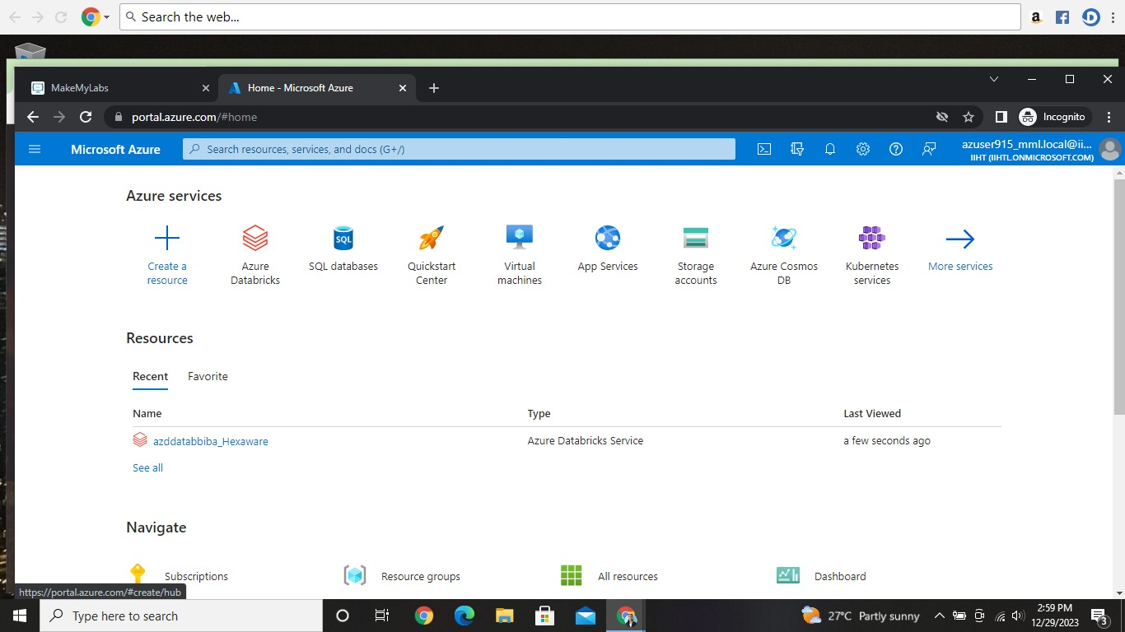

After logging into Azure account created a cluster in the resources called “azddatabbiba_Hexaware”. The process of creating cluster page look like,

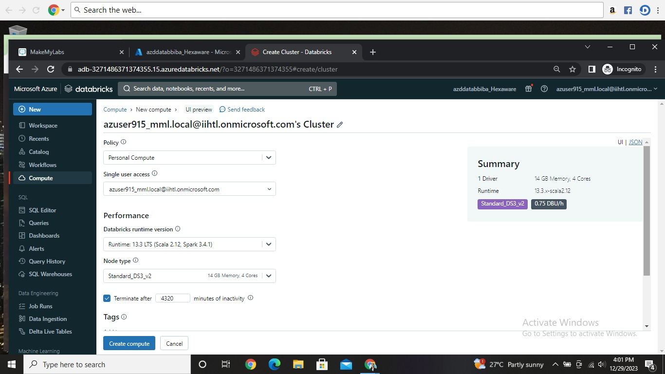

After successfully creating the cluster the page looks like as below .

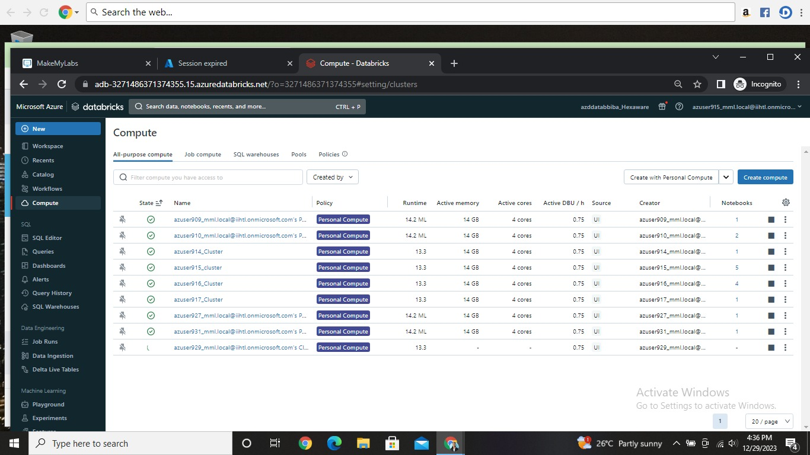

I Created a cluster with name of “azuser915_cluster”. In that cluster I created a notebook to run some pyspark programs. Here are some example programs which I executed today.

Example-1: Creating RDD

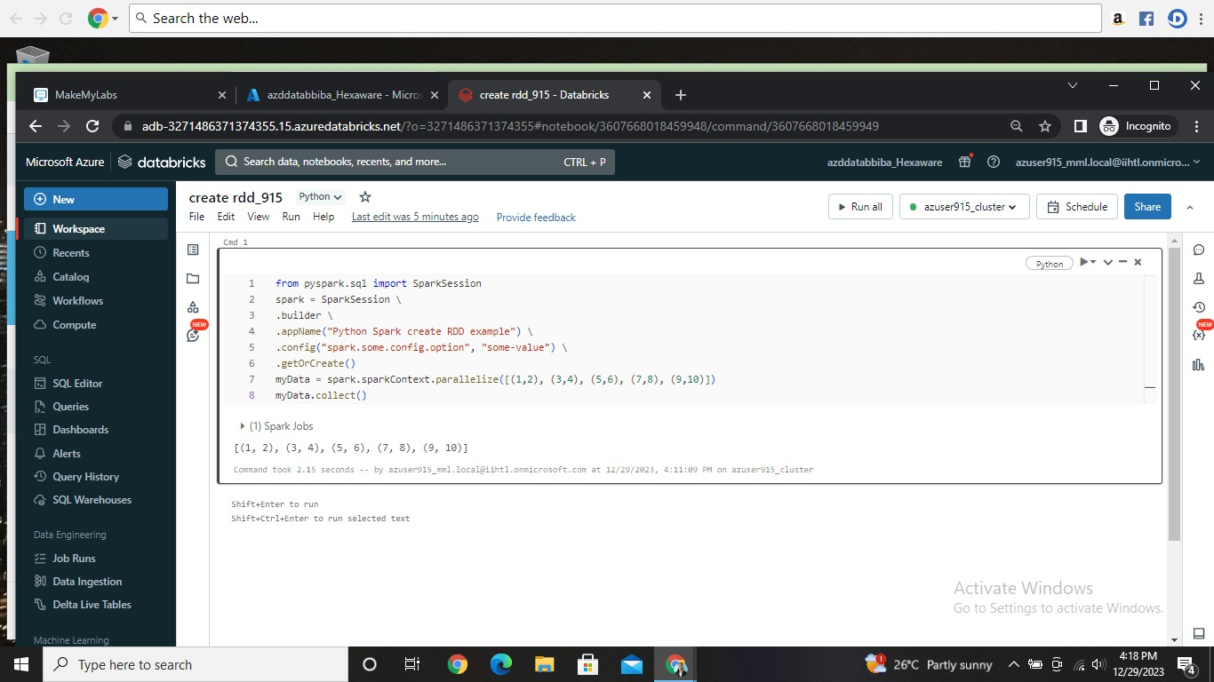

Example-2: Current Date

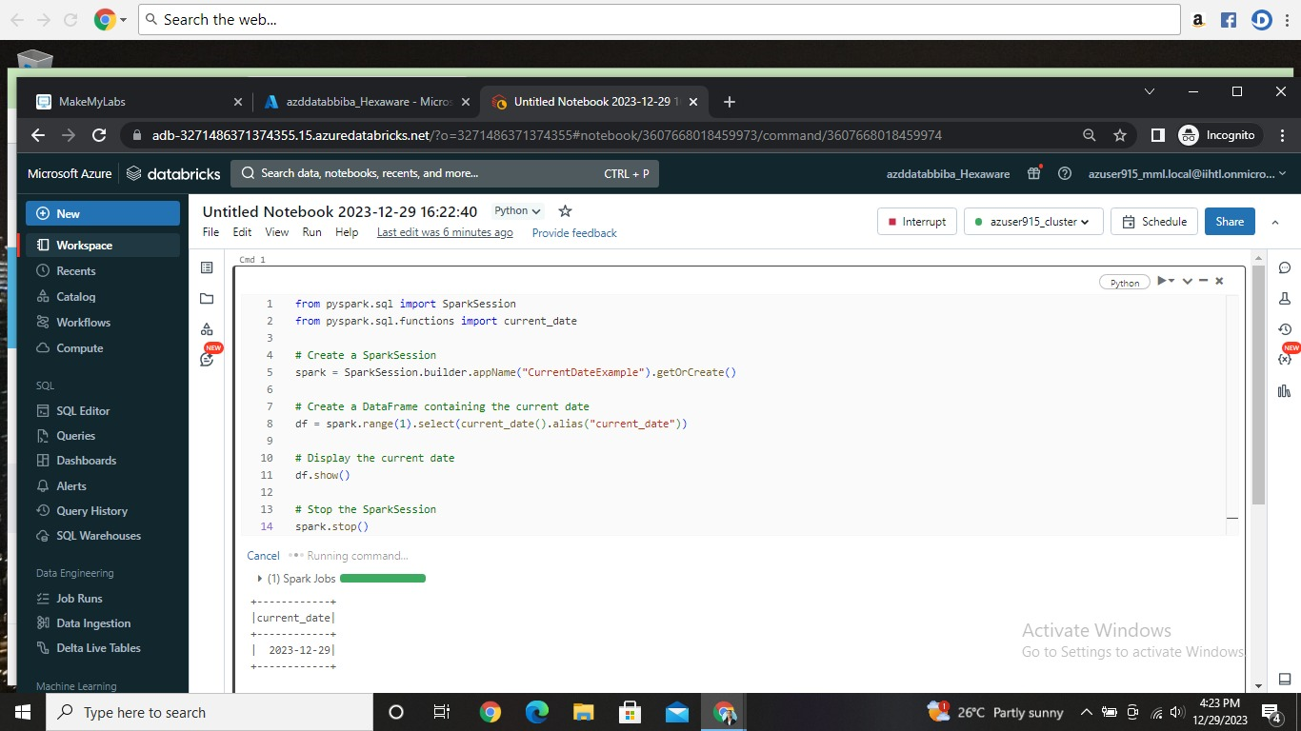

Example-3: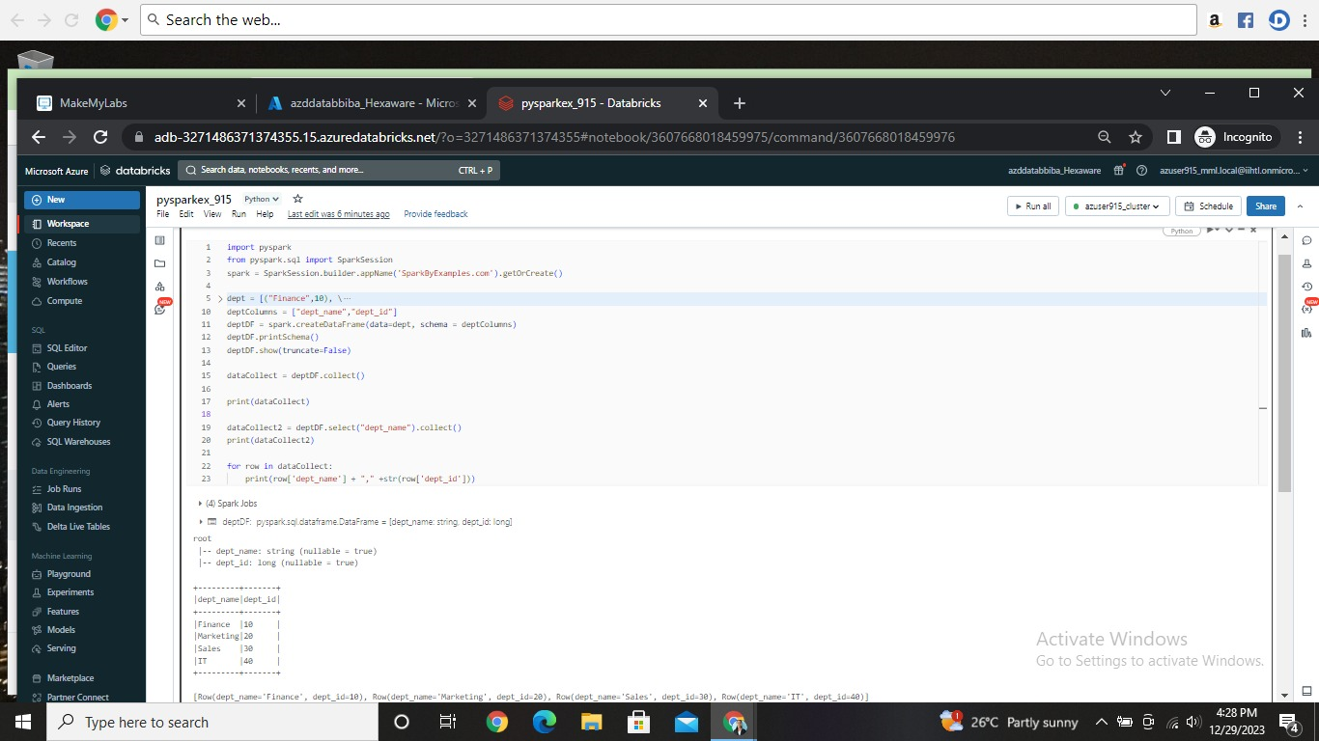

Example-4:Pandas Dataframe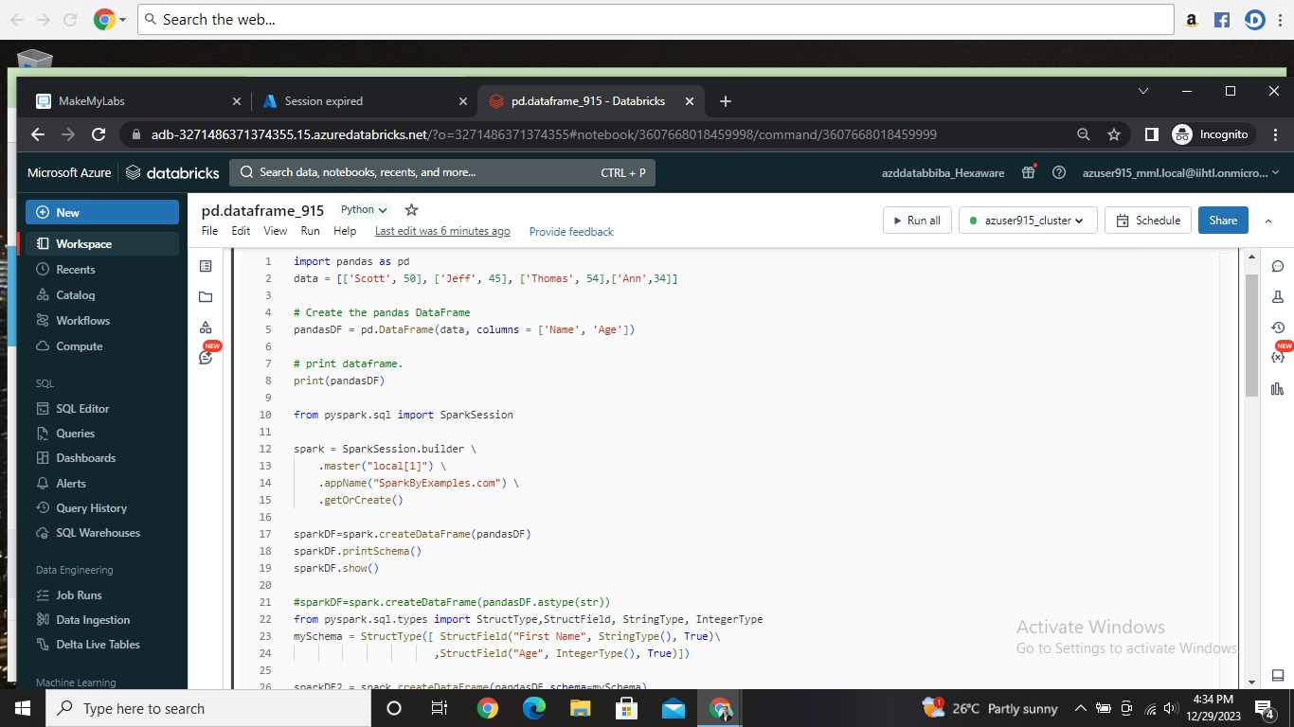

Continueee—

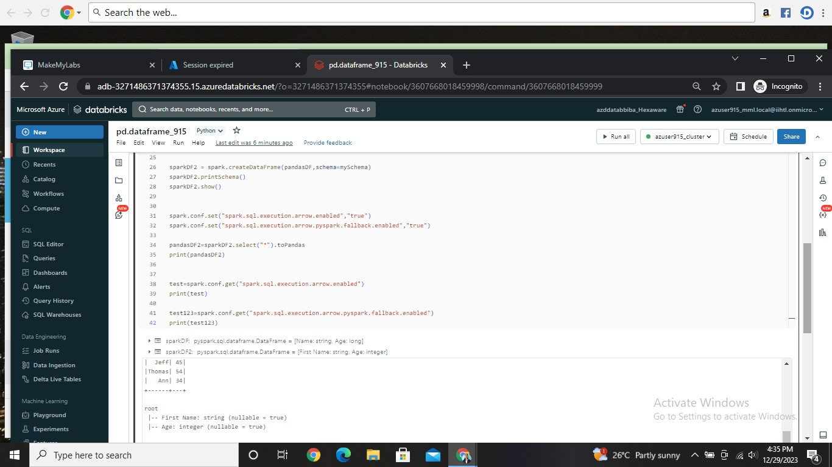

Continue—

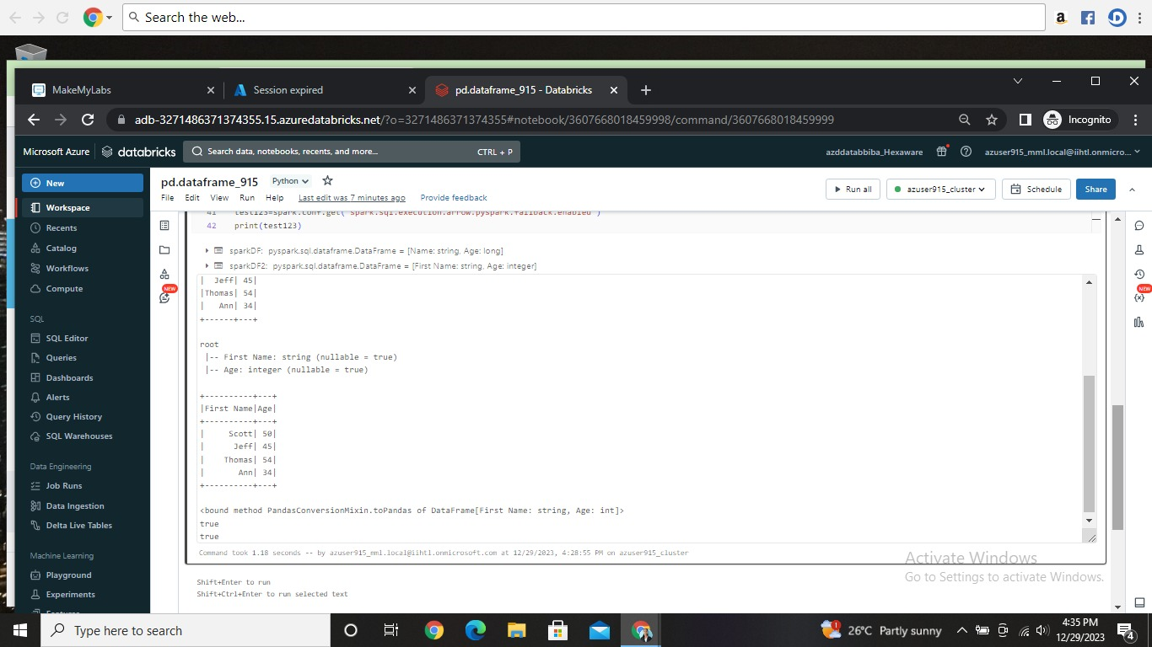

After practicing the pyspark programs in the cluster I deleted the cluster as well.

Here is my workspace.

